echo Html::tag('h3', 'My custom footer block');

$this->endBlock(); ?>

<h1>Blocks usage example</h1>

6. Now, when you open your /index. php?r=site/blocks page, you should get your IP just before the page content and a built-with note in the footer:

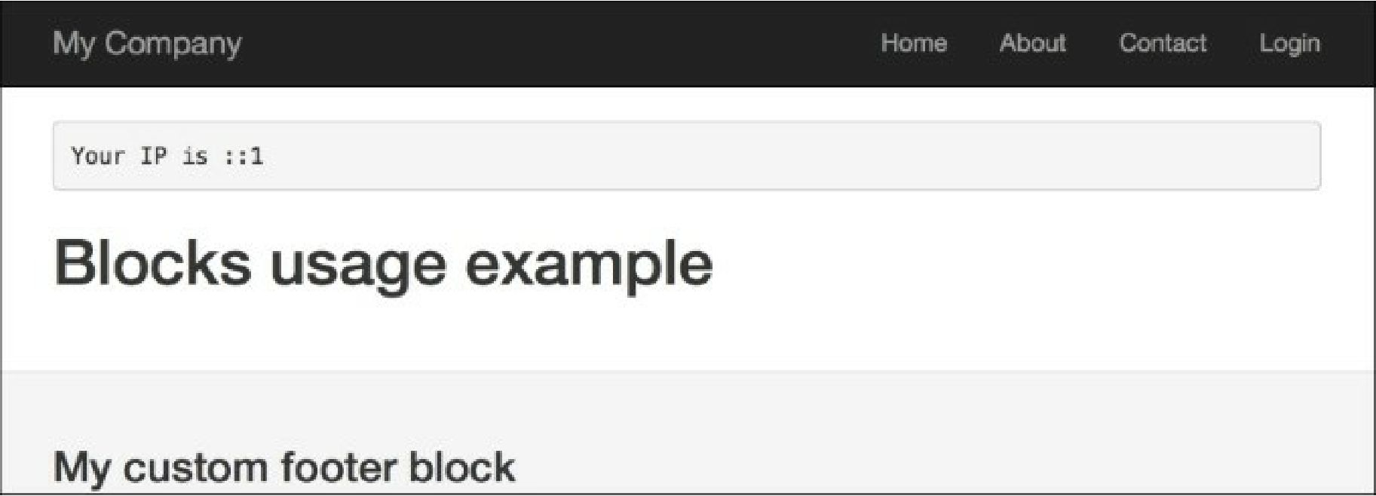

How it works...

We mark regions with the code that just checks for the existence of a specific block, and if the block exists, the code outputs it. Then, we record content for blocks we defined using the special controller methods named beginBlock and endBlock.

From controller, you can easily access our block’s variables via $this->view->blocks[' blockID' ].

There’s more.

* The Using the controller context in a view recipe
* [http://www.yiiframework.com/doc-2.0/guide-structure-views.html#using-blocks](http://www.yiiframework.com/doc-2.0/guide-structure-views.html%23using-blocks)